Lothersdale Legends

This week’s Lothersdale Legends
have been awarded to:

Reception – Rose Baker
Year 1 – Betsy Rider
Year 2 – Aiden Gill
Year 3 – Freddie Ward
Year 4 – Nicolas Weekes
Year 5 – Thomas Woodhead
Year 6 – Ezra Gallagher

YEAR 6 AWARD
This week’s Year 6 Award goes to
SAM WOODHEAD

Health & Safety Update

School Bookbags
Please note that children in Class 1 and Class 2, who have a large bookbag, must have the strap removed for health and safety purposes.

If you are ordering a new bookbag for your child, please note the following:

Class 1 and Class 2 ~ large standard bookbag without strap
Class 3 and Class 4 ~ large standard bookbag with strap

The above bookbags form part of the school’s uniform policy and no other type of bookbag should be brought into school (ie., rucksack, flight bag, etc) as unfortunately the school does not have the capacity to store these bags in classrooms and it therefore poses a health and safety risk. Please note that additional items of clothing/footwear for PE or after school activities must be brought in as small a bag as possible.

Deadlines & Reminders for w/c 22 May 2017

Mon | -  -  -  - | Deadline for payment of Extended Schools Clubs for Summer Second Half  Deadline for payment and return of reply slip for Class 4 visit to Murton Park  Class 1 Talking Tables Workshop ~ 9.00am to 10.30am  Year 4 Eshton Grange Parents Information Evening at 6.30pm
Tue | - | LSA Meeting in school at 7.30pm ~ everyone welcome to come along
Wed | -  -  - | Class 1 Walk in Lothersdale Woods  RESCHEDULED DATE: Y5/6 SCS Cricket Festival at Sutton-in-Craven Cricket Ground (selected pupils)  Y4 & Y5 Forensic Science Murder Mystery at SCS (selected pupils)
Thu | -  - | Teddy Bear’s Picnic Lunch  NO FIRST AID CLUB (the training course finished last week)
Fri | -  -  - | ‘Sporty’ Non-uniform Day ~ Craven School Games Charity Bike Ride ~ all children to be in school at 8.30am (see info below)  Class 2 Swimming Lessons  School finishes at 3.15pm for the Spring Bank Holiday

EXTENDED SCHOOLS’ ACTIVITIES ~ w/c 22 May 2017
Monday | Tuesday | Wednesday | Thursday | Friday
French Club  12.25 – 1.00pm  Lego & Construction  3.15 – 4.00pm  Running  3.15 – 4.15pm | Ukulele Club  10.25 to 10.55am  Glee Club  12.25 – 12.55pm  Gardening Club  3.15 – 4.00pm  Jump Rope  3.15 – 4.00pm  Get Groovy  3.15 – 4.15pm  Woolcraft  3.15 – 4.15pm | Board Games & Jigsaws  8.20 – 8.50am  Tag Rugby  3.15 – 4.15pm  Drama KS1 & KS2  3.30 – 4.30pm | Netball  12.25 – 1.00pm  Supersports  3.15 – 4.15pm | Dodgeball  8.15 – 9.00am  Jewellery & Puppet Making  12.25 – 12.55pm  Rugby Tots  3.15 – 4.15pm  Football  3.15 – 4.15pm

Save the Date!
Please note there may be circumstances in which these dates are subject to change.
More information will follow at a later date about events listed below:

Thu 15 Jun 2017 | - | Class Photographs & Year 6 Leavers’ Photographs at 9.30am

What’s Happening in the Classroom and Beyond?

Craven School Games Charity Bike Ride ~ Friday 26 May 2017
Please remember that Friday is non-uniform day and all children should arrive at school in ‘sporty’ clothing at 8.30am. Please ensure they bring £1 with them to donate to Martin House Children’s Hospice and a healthy snack they can eat as part of a special 'Sports Breakfast’. Dodgeball Club will take place at 8.15am as normal.
Class Photographs and Year 6 Leavers’ Photographs ~ Monday 15 May 2017
Our class photographs and Year 6 leavers’ photographs are taken outside and, due to the poor weather conditions on Monday, the decision was taken to postpone the photographer. The photographs have now been rescheduled for Thursday 15 June 2017 at 9.30am. Fingers crossed for good weather!
* Class 1 ‘Talking Tables’ event for parents ~ 22 May 2017 *
Please remember that all parents/carers of children in Class 1 are invited to join
their children in the hall for a story writing workshop called ‘Talking Tables’ on
Monday 22 May 2017

The workshop will last from approximately 9.00am until 10.30am and parents/carers
will be able to enjoy working and supporting their children with their writing.

Mrs Bateman looks forward to seeing you all on Monday morning.
Class 1 Visit to Skipton Town Hall Museum ~ Tuesday 16 May 2017
Class 1 had a fantastic time at Skipton Town Hall Museum on Tuesday. The Curator of the Museum was excellent and really welcomed the children. They got to see a doll that was 150 years old and a teddy bear that was 80 years old. Everyone really enjoyed their picnic lunch before returning to school.

Class 1 Walk in Lothersdale Woods ~ Wednesday 24 May 2017
Mrs Bateman, Miss Laycock and Mrs Binns will be taking Class 1 children to Lothersdale Park and woods on Wednesday 24 May 2017. Please ensure your child has wellies and clothing appropriate for the weather conditions on the day. If sunny, please ensure they have a hat in school and suncream has been applied prior to coming into school.

Class 3 & Class 4 ~ Climbing Competition at High Adventure in Cowling
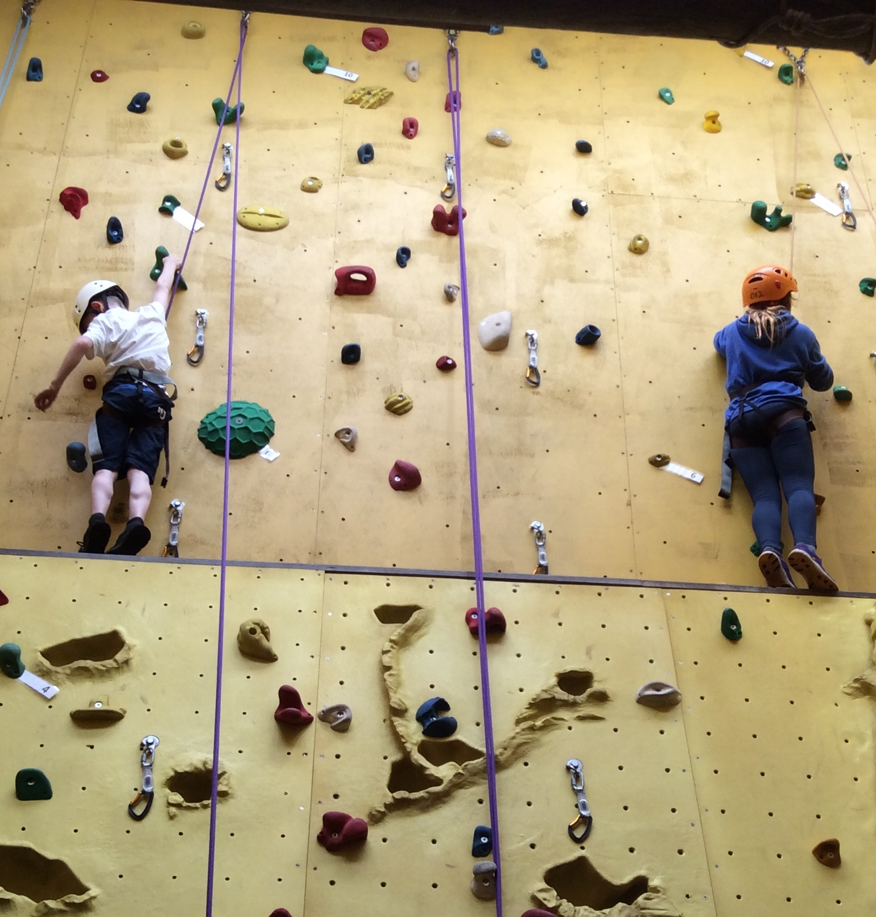
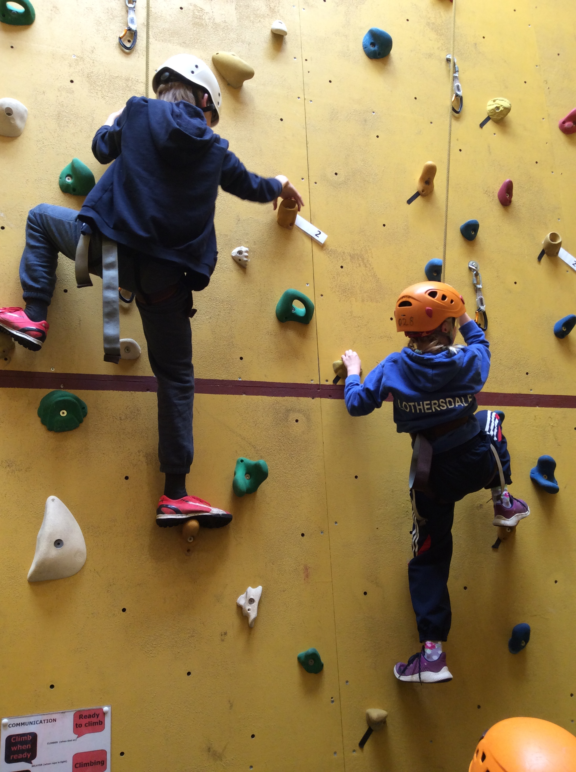
Well done to our climbing teams who had a great afternoon at High Adventure on Monday.

All the children did really well and there are lots more climbing photos on the school website for you to view.

Some schools are still competing next week so we will not know if they have progressed to the next round until all the schools have finished the competition.
Year 4 ~ Eshton Grange Parents’ Meeting ~ Monday 22 May 2017
Please remember the Eshton Grange Parents’ Meeting for Year 4 children will take place on Monday 22 May 2017 in school at 6.30pm and will give parents the opportunity to ask any questions. Please note that pupils should not attend as this enables parents/carers to freely discuss any concerns they may have. Pupils will be able to discuss the visit in class with Miss Gallagher and Mrs Severs nearer the time of the visit.

Year 4 ~ Eshton Grange Residential Visit ~ Outstanding Payments
Please note that the deadline for full payment for the Year 4 residential visit to Eshton Grange on 7 to 9 June 2017 is today, Friday 19 May 2017. We still have several payments outstanding and would be grateful if payment could be made by Monday 22 May 2017.

Y4 and Y5 ~ SCS Forensic Science Mystery Event ~ Wednesday 24 May 2017
Good luck to our teams of ‘forensic scientists’ from Year 4 and Year 5 who will be competing against local schools at the Forensic Science Mystery event at South Craven School on Wednesday 24 May 2017.

RESCHEDULED: Year 5/6 SCS Cricket Festival at Sutton-in-Craven Cricket Ground ~ 24 May 2017
Unfortunately the SCS Cricket Festival scheduled for Wednesday 17 May had to be postponed due to the poor weather and will now take place on Wednesday 24 May. Good luck to Ezra, Ty, Ben, Tess, Hannah, Nyima, Oliver and Sam who will be competing next week. Please ensure children are collected from the cricket ground at 4pm prompt.

Year 6 Spelling Group
Please note that, as indicated in the Friday News dated 7 April 2017, the Year 6 Spelling Group has now finished (the last session took place on Thursday 4 May 2017).

Extended Schools ~ First Aid Club
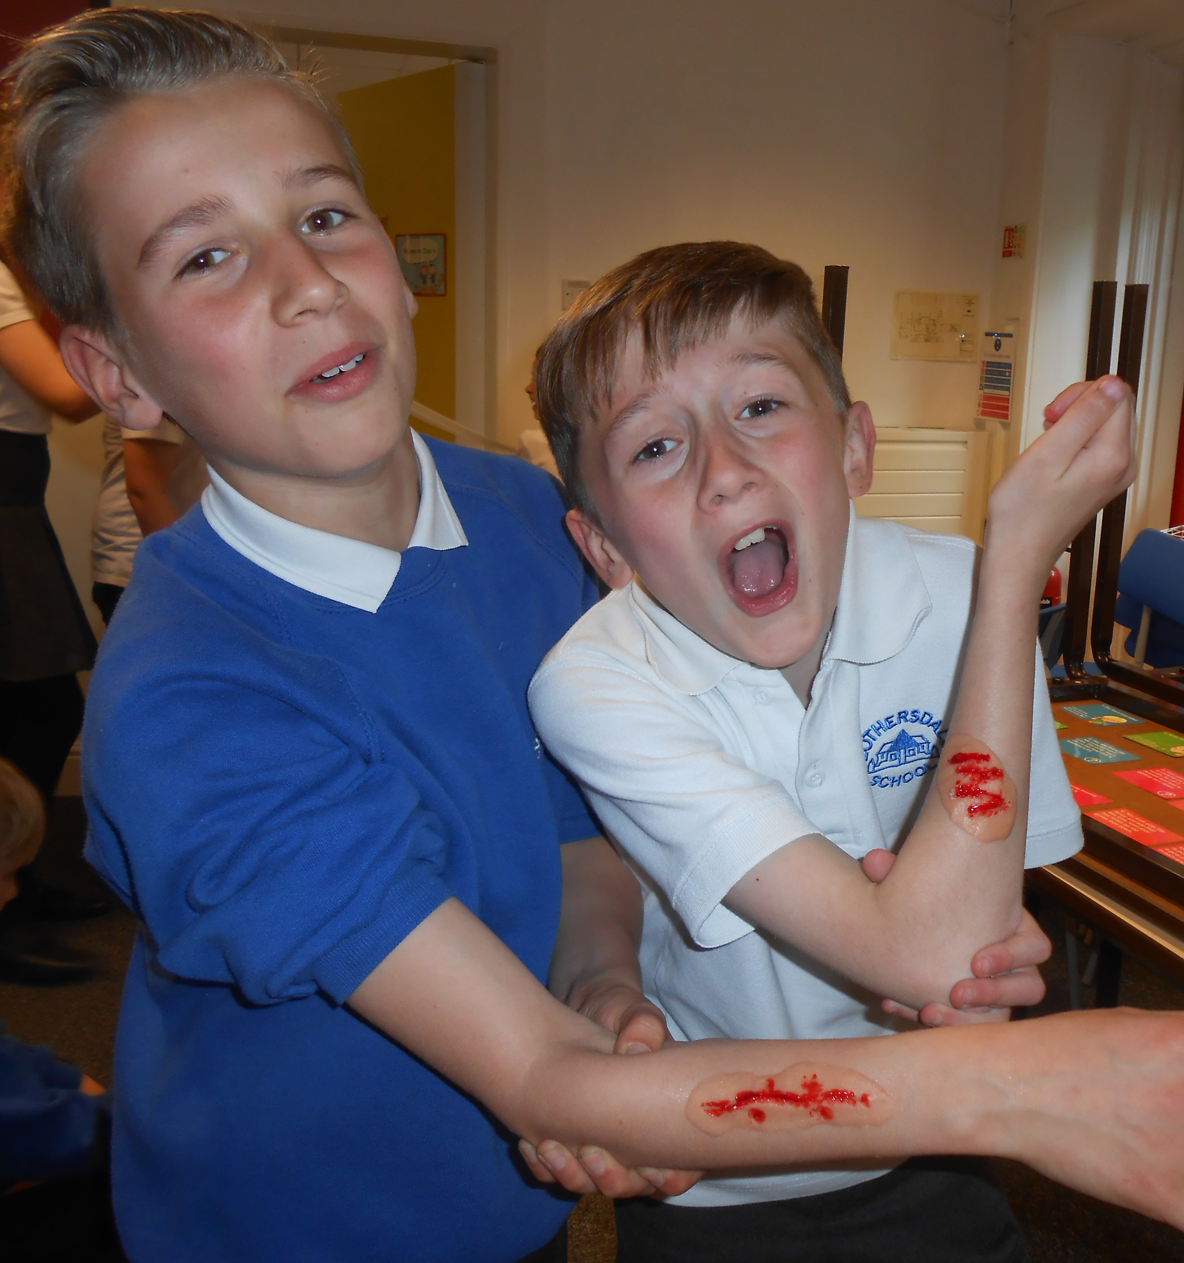
Our Thursday Extended Schools First Aid Training has now finished and we have another 7 First Aiders in Class 4, making a total of 16 pupils trained in first aid! Well done to Joseph, Ty, Ben, Archie, Lily, Sam and Thomas, who have been awarded their certificates today in assembly.

Over the last term our first aiders have learnt how to treat burns, bad cuts, asthma, allergies, broken bones and choking.

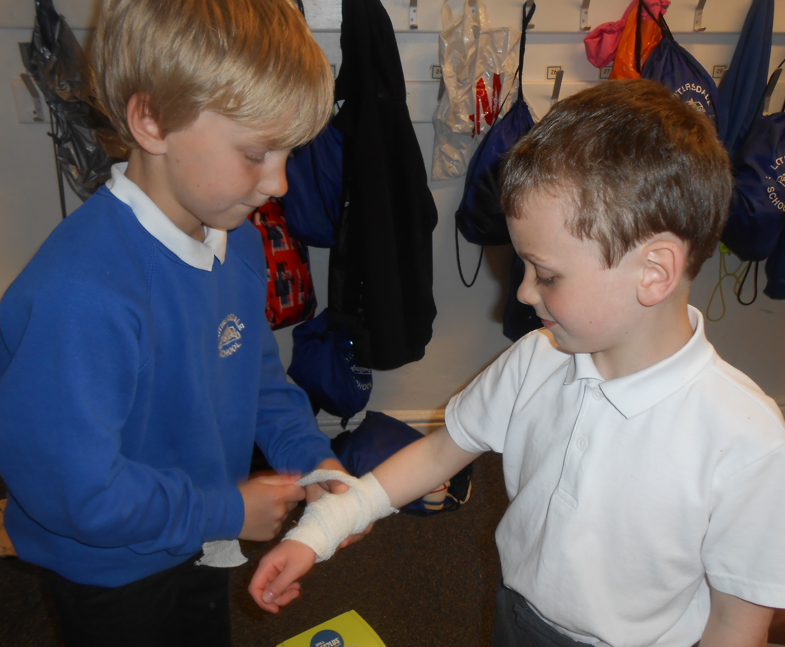
They have also completed their CPR training.

We are very proud of them all!

We would also like to thank Malcolm Linford from Heart Start, who came in to support Mrs Burgess with CPR training.

Extended Schools ~ Summer Term Second Half
Extended Schools ~ Gymnastics
Club 1 (3.15 to 4.15pm) ~ this club is now full however if you live in the village and are able to send your child to the later club, please contact the school office so that the place can be offered to another child who is unable to attend the later club.
Club 2 (4.20 to 5.20pm) ~ there are currently 9 places available on this club. Please remember that Lothersdale Out of School Club is also able to take children after school if your child wishes to take part in this club.

Extended Schools ~ Tag Rugby (Rounders after half-term)
Please note that Mr Craven will now be running a Rounders Club on Wednesday after school from 3.15 to 4.15pm instead of Tag Rugby. This is by popular demand ~ the children have asked for rounders after half term. If your child has been doing Tag Rugby and does not want to continue with rounders, or your child would like to join rounders after half term, please let the school office know on Monday 22 May 2017.

STAFF LED/FREE CLUBS: will continue as per the lists for this half-term. Please inform the school office by Thursday 25 May 2017 if your child no longer wishes to continue with a particular staff led club or, alternatively, your child wishes to join a club (and there is space). Please note however that children who have consecutively failed to attend a club for the last three weeks, will be removed from the activity list and the place offered to another child. Places available on staff led/free clubs are detailed below:

Monday Running 3, 4, 5, 6 2 places
Tuesday Gardening 2, 3, 4, 5, 6 2 places
Tuesday Get Groovy 3, 4, 5, 6 7 places
Tuesday Jump Rope R, 1, 2 11 places
Wednesday Board Games 2, 3, 4 9 places
Wednesday Rounders (was Tag Rugby) 3, 4, 5, 6 6 places

PAID CLUBS: please ensure payment is made via ParentPay by Monday 22 May 2017 to secure your child’s place on their chosen club. Places on these clubs go quickly and it is advisable to pay as soon as possible. Please note that the activities will be removed from ParentPay once the deadline has passed and, unfortunately, we will be unable to add your child to an activity list after this date.

Double Take Drama ~ Musical Theatre Workshop of ‘Grease’
Double Take, our Extended Schools drama provider, will be rehearsing and performing ‘Grease’ for the Musical Theatre Workshop taking place on Monday 14 August to Thursday 17 August 2017 from 10am to 3pm each day at Keighley Rugby Union Club in Utley. The drama club is very popular with Lothersdale pupils and anyone can take part from age 6 upwards. If you would like to book a place on this workshop, please see the flyer attached to this newsletter for further details.

Lothersdale Out of School Club / Holiday Club Update

Holiday Clubs
Spring Bank Holiday – unfortunately, due to the lack of take up for places, the Holiday Club is unable to open in the half-term holidays due to financial viability.
Summer Holidays – we are now planning for Holiday Club in the summer holidays. We will be open for the first four weeks on Tuesdays, Wednesdays and Thursdays. Please book as soon as possible if you would like your child(ren) to attend.

Lothersdale Out of School Club
For clarification for those children who are booked into the Out of School Club on a permanent basis, fees must be paid in full before the 20th of each month, regardless of whether your child attends or not.

School Office and Updates

Change to School Lunch Menu
Please note there is a slight change to the school lunch menus on a Tuesday and a Thursday as the children have not taken to sunflower seeds or courgette and carrot ribbon salad.

Tuesdays ~ coleslaw will now be served instead of sunflower seeds
Thursdays ~ sweetcorn and carrots will now be served instead of courgette & carrot ribbon salad.

School Deadlines
May we remind parents/carers of the importance of returning reply slips and/or making payments by the requested deadlines. Despite text reminders, returned paperwork is still not making it back into the school office and it is becoming increasing difficult for the administrator to maintain deadlines set by other providers. We would be grateful if you could support the school in this matter. Many thanks.

School Contact Information
Please remember that if you wish to contact a member of staff or have a general query, you can email us via lothersdale@ycatschools.co.uk and your message will be passed on to the appropriate member of staff or dealt with accordingly. You can also use the contact form available on the school website.

Pupil Medical Information
It is important that school is kept updated regarding any changes to your child’s health. Please inform the school office as soon as possible if your child’s medical details change to enable us to keep our records up-to-date.
Please ensure school is informed if your child has a head bump out of school. This information is vital if your child suffers a secondary head bump in school, as it enables the school to take extra precautions and allow for closer monitoring in this situation.

Friday News Online
Please remember that if you do not receive a hard copy of the Friday News, or mislay the copy sent home every Friday, the newsletters can also be found on the school website for your information.

School Website
Remember to look on our School Website for further information on
what is happening around school!

New Postings on our Website this week:
- Friday News
- Climbing Competition photos at High Adventure - Children ~ Class 3 or 4 page
- Class 4s Automata Project photos – Children ~ Class 4 page

Lothersdale School Association

Next LSA Meeting ~ Tuesday 23 May 2017
The next LSA meeting will take place in school on Tuesday 23 May 2017 at 7.30pm. Everyone is very welcome to come along to this informal evening, which is the perfect opportunity for parents/carers to get to know one another socially and to contribute any ideas towards school events.

Table Top Sale ~ Lothersdale Village Hall ~ Sunday 11 June
The LSA are organising a ‘preloved’ table top sale to continue its commitment to raising funds for the school. The tables are limited and will be on a first come first served basis. Please contact Laura Sykes at Laura-faulkner123@hotmail.co.uk if you are interested.

The cost is £10.00 per table (any money taken on the day is yours) – the event will be at the Village Hall (All tables will be provided). It will be advertised in the local paper/parish magazine and various notice boards. A pop-up café is being organised with tea/coffee/cake.

If you have lots of unwanted items this could be the opportunity to have a good clear out. However, if you have nothing to sell we hope that you will come along and support the school.

LSA Town Hall Fayre ~ Saturday 1 July 2017
The LSA Skipton Town Hall Fayre is Lothersdale School Association’s biggest annual fundraiser and takes place on Saturday 1 July 2017. It is the only event we hold where we need a lot of volunteers on the day to ensure its success.

For those of you who are unfamiliar with the way this operates, Skipton Town Hall give local charities the opportunity to fundraise by allowing them the use of the Town Hall kitchen and main hall on a specific date.
Stallholders contact the LSA to book a stall in the main hall and pay the LSA a booking fee. The LSA run the Town Hall café and serve hot and cold food all day to members of the public. With this in mind, members of the committee will be approaching you at some point between now and the end of June to ask you to commit an hour of your time on the day to help everything run as smoothly as possible ~ without your help the café would not be able to function commercially.

Jam Jars ~ our jam jar tombola is very popular and all we ask is that each child fills a jam jar and brings it back into school by Friday 23 June 2017. Empty jam jars are now available to take from a box in the main reception area and each jar will have a note included with instructions and ideas for those who haven’t done it before.

If you have more jam jars at home, then you are welcome to bring in more than one. Please ensure, however, that jars containing curry and/or other strong flavoured food are not used as the flavours transfer onto items placed in the jar.

Ideas for filling jam jars:
Crayons, gel pens, pencils, bobbles, hair clips, craft items (eg. pompoms, pipe cleaners, google eyes), rubbers, dinky cars, bouncy balls, miniature soaps etc

SWEETS (please ensure they are wrapped as flavours from the original contents of the jam jars can transfer to the sweets if they are unwrapped)

Tombola ~ this year we are asking classes to donate particular items for the tombola stall as follows:

Class 1 – stationery, crafts and small toys
Class 2 – smellies
Class 3 – chocolates
Class 4 – bottles and jars

Please note that the above items should be new and unopened. Boxes are now available in the main reception area for you to place your items. Thank you for your continued support.

Community Noticeboard
We are delighted to be able to promote community events in our Friday News that may be of interest to our families and friends. If you would like us to promote a local event please pass the details to the school office by Wednesday to be included in the Friday News of that week

Christ Church Lothersdale Café Church ~ Sunday 21 May 2017
Christ Church Lothersdale welcomes you to their Café Church Services on Sunday 21 May 2017 at Christ Church, Lothersdale. Breakfast (bacon butties, croissants, cereal, juice, tea, coffee) is served at 9.00am followed by church worship at 9.30am. Everyone is very welcome to come along and take part in this relaxed atmosphere.
Keighley Women’s Refuge (Bradford Women’s Aid)
Please remember we are have linked up with Christchurch Lothersdale to support Keighley Women’s Refuge and a box is available in the main reception area for any donations you may wish to bring in towards this charity ~ this collection will be ongoing until further notice. Please feel free to place items in the box in the main reception area when you can. The Women’s Refuge provide home starter packs when the families are rehoused, which comprise the following (new) items: Toiletries, cleaning products, cleaning equipment, kitchen equipment (eg pans, plates, mugs), food items (long life food items are ideal, eg tins and packets of food).

If you are able to donate any of the above, they will be gratefully received. Many thanks.

Diary of Events
Please note there may be circumstances in which these dates are subject to change:

School Events:
Mon 22 May 2017 | - | Class 1 Talking Tables Workshop for Parents ~ 9.00 to 10.30am
Mon 22 May 2017 | - | Year 4 Eshton Grange Parent Information Evening ~ 6.30pm
Tue 23 May 2017 | - | LSA Meeting in school at 7.30pm
Wed 24 May 2017 | - | Class 1 Walk in Lothersdale Park/Woods ~ bring wellies!
Wed 24 May 2017 | - | Y5/6 SCS Cricket Festival at Sutton-in-Craven Cricket Ground
Wed 24 May 2017 | - | Y4/5 SCS Forensic Science Murder Mystery (selected pupils)
Fri 26 May 2017 | - | ‘Sporty’ Non-uniform Day ~ Craven School Games Charity Bike Ride ~ all children to be in school at 8.30am
Fri 26 May 2017 | - | School breaks up at 3.15pm
Tue 6 Jun 2017 | - | Class 4 Visit to Yorkshire Farming Museum
Tue 6 Jun 2017 | - | New reception weekly transition visits start at 1.00pm
7 to 9 Jun 2017 | - | Year 4 Residential Visit to Eshton Grange
Fri 9 Jun 2017 | - | Wear purple for JIA (Juvenile Idiopathic Arthritis) ~ Pupil Fundraiser
Sun 11 Jun 2017 | - | LSA Table Top Sale at Lothersdale Village Hall
w/c 12 Jun 2017 | - | Year 1 Phonics Screening Week
Wed 14 Jun 2017 | - | Y3/4 & Y5/6 Rounders Festival at SCS (selected pupils)
Thu 15 Jun 2017 | - | Y5/6 Workshop in school ~ ‘How the human heart works’
Mon 19 Jun 2017 | - | Parent Forum ~ Class 3 & Class 4 ~ 9.00am
Tue 20 Jun 2017 | - | Class 1 Assembly ~ 9.10am
Tue 20 Jun 2017 | - | New Reception Parents’ Welcome Evening
Thu 22 Jun 2017 | - | Parent Forum ~ Class 1 & Class 2 ~ 9.00am
w/c 26 Jun 2017 | - | Arts Week (Woodland Theme)
Tue 27 Jun 2017 | - | Class 3 Assembly ~ 9.10am
Tue 27 Jun 2017 | - | Y1/2 Mini Olympics at South Craven School ~ 4.00 to 6.00pm
Wed 28 Jun 2017 | - | Year 5 Day at SCS
Thu 29 Jun 2017 | - | Year 6 Transition Day at Skipton Girls’ High School
Thu 29 Jun 2017 | - | Year 6 Transition Day at Ermysteds Grammar School
Thu 29 Jun 2017 | - | Cultural Awareness Day in school
Sat 1 Jul 2017 | - | LSA Town Hall Fayre, Skipton
Mon 3 Jul 2017 | - | Year 6 Induction Day at SCS (Day 1)
Tue 4 Jul 2017 | - | Year 6 Induction Day at SCS (Day 2)
Tue 4 Jul 2017 | - | Class 4 (Year 5) Assembly at 9.10am
Wed 5 July 2017 | - | South Craven School Open Evening ~ Sept 2018 Intake ~ 6.00pm
Thu 6 Jul 2017 | - | Sports Day ~ 1.30pm
Mon 10 Jul 2017 | - | Year 6 ~ Bikeability Training
Tue 11 Jul 2017 | - | Year 6 ~ Bikeability Training
Tue 11 Jul 2017 | - | Class 2 Assembly at 9.10 am
Tue 11 Jul 2017 | - | New Reception Transition/Parents’ School Lunch at 12 noon
Thu 13 Jul 2017 | - | Reserve Sports Day ~ 1.30pm
Fri 14 Jul 2017 | - | All Extended Schools Clubs finish
Fri 14 Jul 2017 | - | Last Class 2 Swimming Lesson
Wed 19 Jul 2017 | - | Year 6 Leavers’ Lunch
Wed 19 Jul 2017 | - | Year 6 Leavers’ Concert (dress rehearsal) ~ 2.00pm
Wed 19 Jul 2017 | - | Year 6 Leavers’ Concert ~ 7.00pm
Thu 20 Jul 2017 | - | Class 1 & Class 2 Leavers’ Disco ~ 6.00 to 7.15pm
Thu 20 Jul 2017 | - | Class 3 & Class 4 Leavers’ Disco ~ 7.30 to 8.45pm
Fri 21 Jul 2017 | - | School breaks up at 3.15pm

Community Events:
Sun 21 May 2017 | - | Christ Church Lothersdale welcomes you to their Café Church Service on Sunday 21 May 2017 at Christ Church Lothersdale from 9.00am.
Sunday 2 Jul 2017 | - | Family Treasure Hunt ~ more details to follow.

