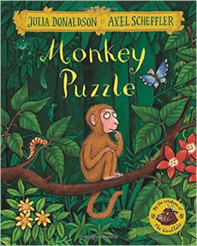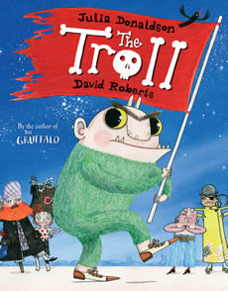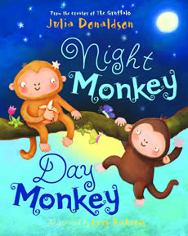

How many great stories do you know by Julia Donaldson?
Bring a selection of your favourites to school so we can all snuggle up with a good book!

Mrs B

