Class 2 Writing Challenge

I hope everyone has enjoyed being out in the snow over the past few days. We would love to hear about something you’ve done this week while not at school. A challenge for this weekend is to take a picture of you out in the snow or of something fun you’ve done this week and write a few sentences telling us what you’re doing and why you had so much fun.

Year 1 – Can you use your capital letters and full stops in the right places? Can you try to use interesting adjectives and joining words to make your writing more interesting?

Year 2 – Can you try to include an exclamation sentence beginning with how or what? What is the most interesting adjective you can use? Can you use any contractions such as wasn’t or didn’t and any words with suffixes such as happiness and enjoyment?

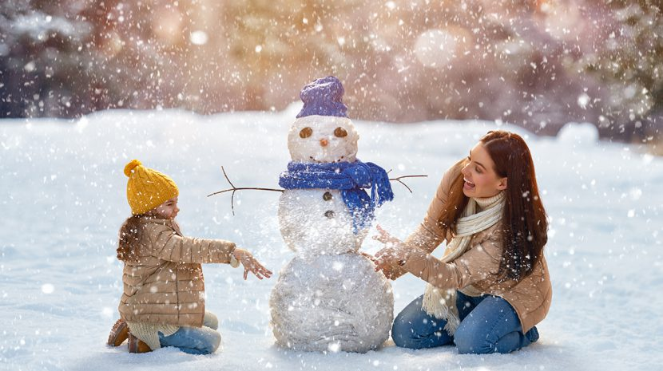
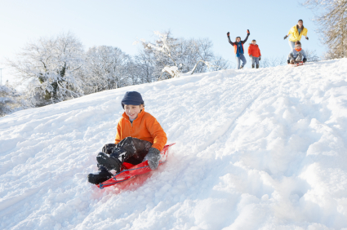
Stay safe this weekend and remember to use your CURSIVE HANDWRITING!

